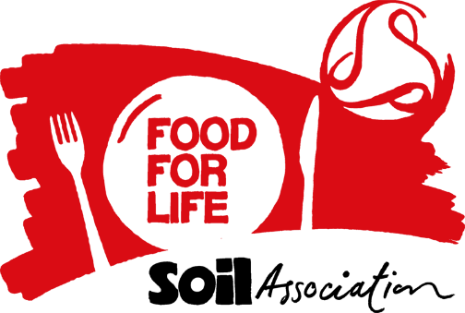

School Council Meeting 5th December 2025
To agree Spring term menus 2026
The school council reps met having discussed the proposed menus with their class and presented their ideas
We like
Chicken curry (can we have one with chickpeas and one without please- on same day.
A sweet potatoes curry is nice- no spinach please!
Chicken Pie/Chicken and veg pie (not on the menu presently)
We like a Cajun chicken wrap- but have it with salad please- not fried onions and peppers
Mayonnaise to have with food & Sauces red (ketchup) / BBQ
Lamb burger/ Chicken kebab/ fish burger and chicken drum stick – keep these.
Mac & Cheese, Pizza baguette (lots please)
More rice options from different cultures ( not just British and USA food) eg. spicey rice
Taco Tuesday please!
Chinese stir fry & Mixed veg stir fry
Carrots only if raw- don’t like them cooked- raw peppers too.

No Thanks to:
Gammon
Pasta Bolognese
Vegetable meatballs
Cheese and potato pie ( our cook, Gwen, said only 60 children choose this)
Breaded Pollack- change to a different type of fish please
Quorn Burger
Hot dog with onions
No Thanks to Thick gravy- can we have thin gravy
Ratatouille- made of tomatoes, courgette and herbs

We will try it but really not sure
Cottage pie
Leeks

Desserts
Not keen on the ice cream unless its chocolate flavour
Like brownies please, chocolate hedgehogs and chocolate concrete, chocolate cake and chocolate fudge cake
Strawberries and ice cream
Trifle
Will try jelly with fruit in it. Prefer different colour jelly and not so runny
Like vanilla sponge- with sprinkles
Can we have a blue cake? & jam doughnuts.
To drink
Orange juice and milk some days as well ss the water.
Query- when can new menus start?
Can pupils have school dinner some days of the week- not every day?
In attendance
Maddox – Owls
Deen 3.2
Khadija 3.4
Hawa Noor 4.2
Arham Muhammed 4.3
Azaan 5.3
Fatima 5.4
Sophia 6.2
Akram 6.4
Gwen- school cook & Mrs Chahal (HT) apologies Tracey (Citiserve)

