Snow activities
Can you build a snowman? Use things you find in the garden or park to make his eyes, nose, mouth, arms and any other features you want to give him.
Please send in a photo of your snowman and you can tell us all about it next week.
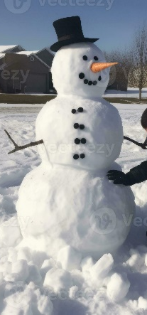

Collect some snow and ice in a pot/bowl and bring it into the house. What happens to the snow and why?
Ask a grown up to video you and send it in to us.
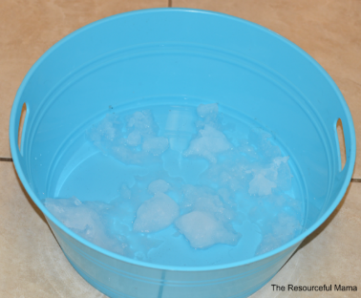

Make footprints in the snow. Can you make a picture using your footprints? What shapes have you made? Can you count your footprints? Who has made the largest footprint? Can you spot any animal footprints and can you guess which animal made them?
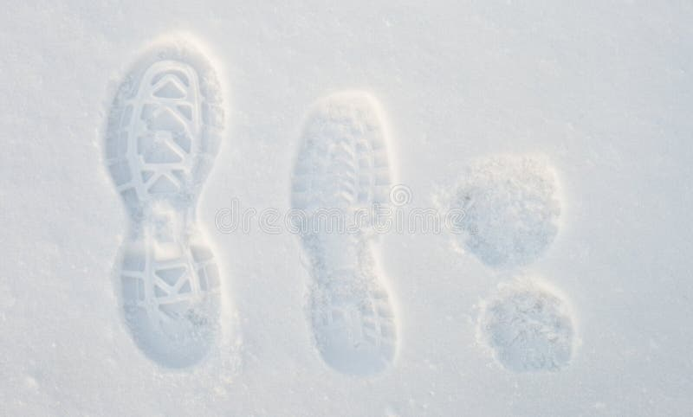
Send us in some photos!

Remember - to have fun in the snow you need to wrap up warm, wear your wellies and move slowly so you don’t trip and fall.

