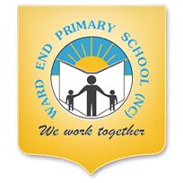
Please see Dojo for remote learning.

Reading - Talk 4 Writing

Please talk to your child about what they have learnt about Winter.

Draw a picture of a snowman and label it.
My snowman is ___________
Phonics
Please see Dojo.
Maths - Number
Practise counting out 5 or 6 objects.
Draw your objects on a piece of paper.
Watch the video from BBC I player.

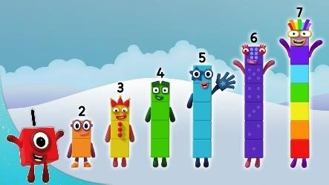

Numberblocks - Series 1: Hide-and-Seek - BBC iPlayer

