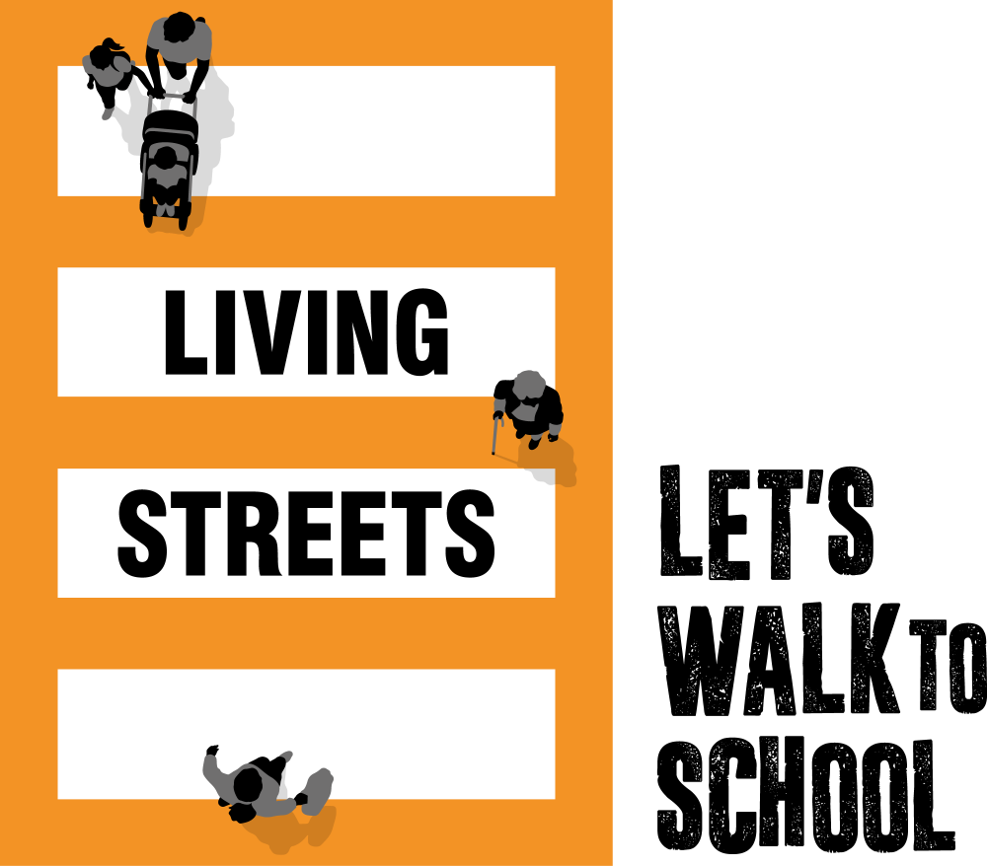


23.1.26

Dear parent/carer,
Living Streets’ WOW – the walk to school challenge is back to help encourage as many children as possible to experience the benefits of walking and wheeling to school.
WOW is a pupil-led initiative where children self-report how they get to school every day. If they travel actively (walk/wheel, cycle, scoot ‘Park and Stride’ or hop off) at least once a week for a month, they get rewarded with a badge. It's that easy!
What are the benefits of walking to school?
- Children feel happier and healthier
- They arrive at school refreshed and ready to learn
- Helps reduce congestion and pollution at the school gates What if we can’t walk to school?
If driving, ‘Park and Stride’ to help your child earn their WOW badges. ten minutes away from the school and walk the remaining journey.
If using public transport, hop off at least ten minutes away and walk the rest of the way (recorded as ‘other’ on the WOW Travel Tracker).
Where walking to school isn’t an option, we work with schools to establish a bespoke approach to WOW that works best for their pupils’ needs. This includes pupils becoming WOW Ambassadors, leading assemblies, creating active travel notice boards, and other activities within the school day.
If you have any questions on the adaptability of WOW or have suggestions of how we can improve, we would love to hear your thoughts. Please email walktoschool@livingstreets.org.uk
The WOW badges
There are 11 new WOW badges to be earned, one for every month of the school year. Each badge has been designed by a pupil as part of our annual WOW Badge Design Competition.
WOW 2025/26 encourages pupils to Walk with Joy, with badges depicting everything from jumping in puddles to painting.
The badges are made in Cornwall from material that was otherwise destined for landfill, including fridge trays, plastic plates and yoghurt pot off-cuts. For more information, visit: livingstreets.org.uk/recycling

Last year, around 2,100 schools and over 540,000 pupils across the UK enjoyed the benefits of walking to school with WOW. Will you join us?
If you have any questions about the programme, find more information and useful videos at: livingstreets.org.uk/wowlaunch Let’s swap those school runs for school walks.
Mrs Chahal

