Home learning
25.06.26

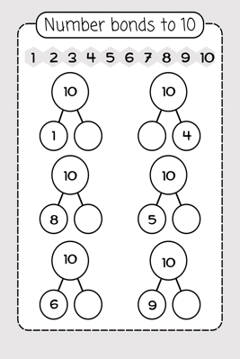
Hi everyone for today’s learning can children practice number formation 0-20. Can children find the different ways to make 10, for example 10 is made of 4 and 6.

Number blocks episode
https://www.bbc.co.uk/iplayer/episode/b08q39b4/numberblocks-series-2-just-add-one?seriesId=b08bzfnh-structural-2-b0bl5v3r

Can children draw and design their own bucket like Billy from the story and write about the things they would put in it.
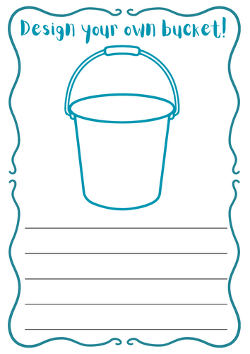

Can you send a video of your child talking about a sea creature they have researched via DOJO

Thank you for all of your pictures and videos so far!

